使用seaborn绘制漂亮的热度图


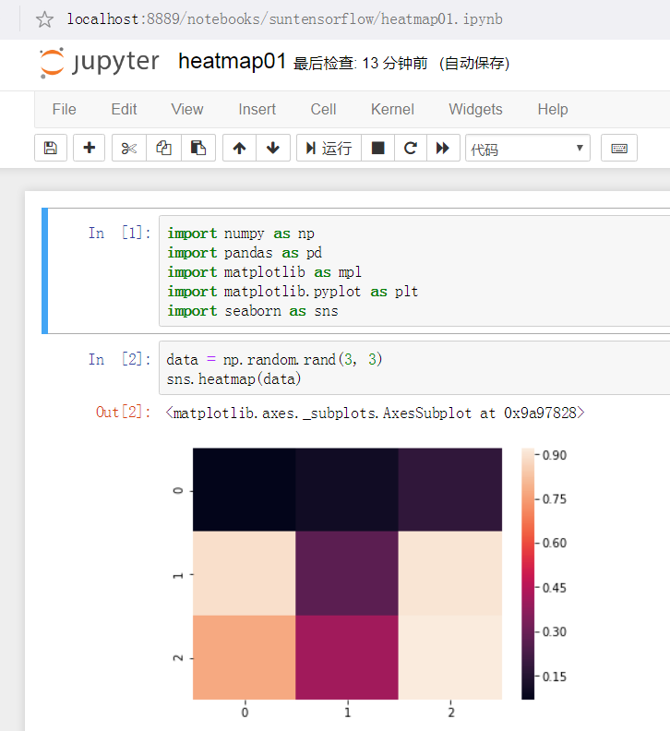

sns.heatmap(data)
sns.heatmap(ndata, center=0)
ax = sns.heatmap(flights, fmt='d', linewidths=.5)
ax = sns.heatmap(flights, fmt='d', linewidths=.5, cmap='YlGnBu')
sns.heatmap(df,annot=True)
ax = sns.heatmap(uniform_data, vmin = 0.2, vmax = 0.5)

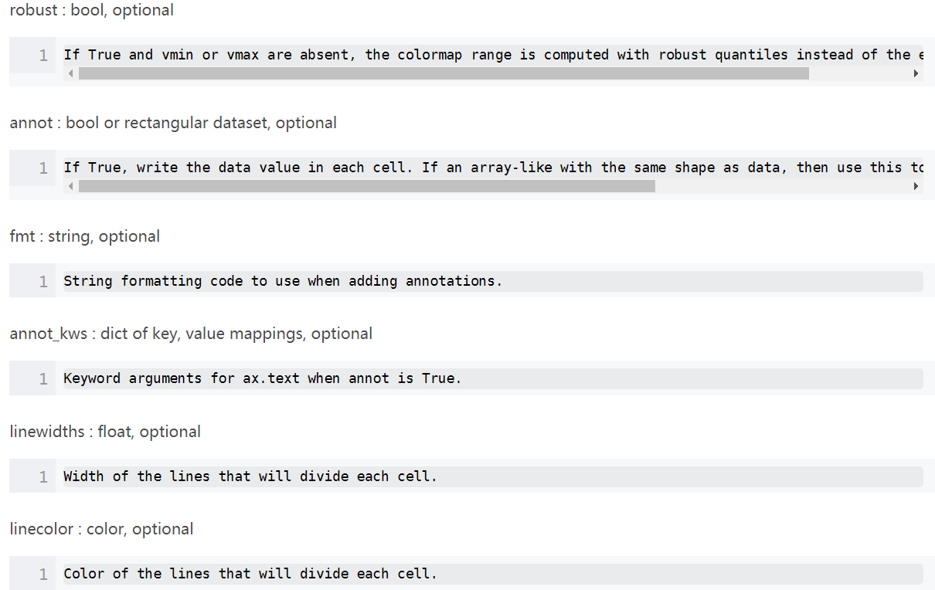

参考：
https://www.zhihu.com/question/55802200
https://blog.csdn.net/wangbowj123/article/details/79325523
https://blog.csdn.net/kenfan1647/article/details/83380305

